**DSM Lab Report**

**Name:** Anirudh Kaushik

**Roll No:** 2020111015

**Group Number:** 5

**Experiment Part A**

**Objective**

To design an Arithmetic and Logic Unit (ALU) capable of performing 8 Arithmetic/Logic functions on 1-bit operands:

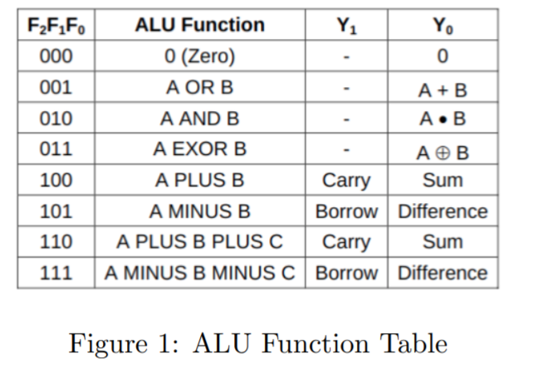

**Experiment setup/ procedure**

**Materials required:**

|  |  |
| --- | --- |
| 3 | Hex Inverter |
| 8 | Dual 4-Input AND gate |
| 5 | Quad OR gate |
| 1 | Blue LED |
| 2 | 1 kΩ Resistor |
| 1 | Red LED |
| 3 | Quad AND gate |
| 1 | Arduino Uno R3 |
| 1 | Quad XOR gate |
| 6 | Slideswitch |
| 1 | Voltage Multimeter |

**Procedure:**

1. The final ALU output bits Y0 and Y1 will be generated by the two 8-input

multiplexers – referred to as MUX0 and MUX1 respectively. The required

data, select and output enable inputs of MUX0 and MUX1.

1. Note that MUX0 is always enabled, while MUX1 is enabled only when F2

= 1, i.e. for Arithmetic functions only. This is because Y1 is required only

to provide the CARRY/BORROW output for Arithmetic functions.

1. Verify theoretically that MUX0 and MUX1 do generate the outputs Y0

and Y1 as required by Fig. 1

1. Given a circuit with two 8:1 MUX, design the ALU
2. Give F0,F1,F2,A,B, and C as input from an arduino.
3. Apply all the combinations of the Function select inputs F2F1F0 one by one and tabulate the observed outputs Y0 and Y1 for as many combinations of the data inputs A, B, C as possible. Verify that the tabulated results conform to the ALU functions given in Fig. 1

**Code:**

slide switches used instead of Arduino as per instruction.

**Observations**

**A+B+C truth table**

|  |  |  |  |  |
| --- | --- | --- | --- | --- |
| A | B | C IN | SUM | CARRY |
| 0 | 0 | 0 | 0 | 0 |
| 0 | 0 | 1 | 1 | 0 |
| 0 | 1 | 0 | 1 | 0 |
| 0 | 1 | 1 | 0 | 1 |
| 1 | 0 | 0 | 1 | 0 |
| 1 | 0 | 1 | 0 | 1 |
| 1 | 1 | 0 | 0 | 1 |
| 1 | 1 | 1 | 1 | 1 |

**A-B-C truth table**

|  |  |  |  |  |
| --- | --- | --- | --- | --- |
| A | B | C | DIFFERENCE | B out |
| 0 | 0 | 0 | 0 | 0 |
| 0 | 0 | 1 | 1 | 1 |
| 0 | 1 | 0 | 1 | 1 |
| 0 | 1 | 1 | 0 | 1 |
| 1 | 0 | 0 | 1 | 0 |
| 1 | 0 | 1 | 0 | 0 |
| 1 | 1 | 0 | 0 | 0 |
| 1 | 1 | 1 | 1 | 1 |

**A-B TRUTH TABLE**

|  |  |  |  |
| --- | --- | --- | --- |
| A | B | DIFFERENCE | BORROW |
| 0 | 0 | 0 | 0 |
| 0 | 1 | 1 | 1 |
| 1 | 0 | 1 | 0 |
| 1 | 1 | 0 | 0 |

**Conclusion**

Successfully made an ALU with 2 8-to-1 multiplexer and verified its functions and plotted the truth table for 3 of its functions along with observing outputs for other operations.

**Tinkercad link with circuit**

Edited out

**Circuit Diagram**

**Pls scroll down**

|  |
| --- |
|  |